Camden and US 31 S Well Survey 2019
Note: 8 digit numbers below refer to virtual file cabinet documents listed under agency ID #100884

Background
The Arlo Price Dry Cleaners, located at 7007 US HWY 31 S IN Indianapolis, 46227 Marion County, Indiana was in operation prior to 2014 and believed to have been responsible for groundwater and soil contamination. This facility operated using 3 dry cleaning machines, each using perchloroethlene (also known as tetrachloroethlyne or “PERC”), which is a commonly used dry-cleaning solvent. A Phase II Environmental Site Assessment (ESA) was conducted in 2014 following Phase I ESAs in 2012 and 2014 (#80462706). Their findings suggest that during normal operations one of the three dry cleaning machines had a leaking pump. Since then Clean by Deering (another dry cleaner) has rented the facility and is currently in operation, and the ownership for the retail building has been transferred to Paragon Southport LLC (82708864). This incident contaminated the groundwater and therefore further investigations are being conducted by the Indiana Department of Environmental Management (IDEM) (82816215).
2019 Survey Results
Starting in July 2019 the Marion County Public Health Department (MCPHD) began offering free well water sampling to the residential well owners within a ¼ mile radius of the dry cleaning facility. It was determined that an estimated 59 properties were utilizing well water within the ¼ mile radius. Each resident received a letter expressing interest in sampling their groundwater for bacteriological and chemical parameters. Well logs, when available, were also sent to the residents who participated in the survey. Out of the possible 36 properties, 9 of them were on municipal water. Out of the remaining twenty-seven (27) properties, 12 participated in the survey resulting in 44% participation.
Sampling Results
Bacteria
No E. coli bacteria were found in the samples taken, but total coliform bacteria were present in 8 samples. Results were unsatisfactory for total coliform bacteria in 67% of the private wells sampled, which is consistent with other well survey results. Chlorination instructions were sent out with the lab reports and follow-up sampling was offered.
VOCs
No volatile organic compounds were detected in any of the well samples. This includes the targeted dry cleaning solvent PERC.
Anions
Well samples were tested for the following anions: Chloride, Fluoride, Nitrates, Nitrites, Phosphates, and Sulfates. No wells had anion levels above the EPA’s Maximum Contaminant Level (MCL).

Metals
Samples were analyzed for the following metals: Arsenic, Barium, Boron, Cadmium, Calcium, Chromium, Copper, Iron, Lead, Magnesium, Manganese, Mercury, Molybdenum, Nickel, Selenium, Thallium, and Zinc. Arsenic was present in 10 of the 12 private well samples with the highest level reaching 8 parts per billion (ppb). Note that all levels were below the EPA’s MCL of 10 ppb. Arsenic is an element that occurs naturally in soil and bedrock throughout Marion County. Long-term exposure has been linked to increase risks of skin, bladder, lung, liver, colon, and kidney cancer. Homeowners were encouraged to continue sampling for levels of arsenic annually or contact a well water treatment provider.
Conclusions
In conclusion, the primary contaminant found during this groundwater survey was total coliform bacteria. There are many factors that can contribute bacteria growing in wells. One of which would be that the homes sampled are older and have wells that have never been chlorinated before. Another factor observed during the survey was the number of wellheads completely buried. These homeowners were advised to locate and extend their wellhead cap 12 inches above the surface by contacting a licensed well driller.
VOC samples were below detection level (BDL) for all 12 private wells sampled. These samples tested for a number of chemicals including PERC, which suggests that PERC released at 7007 US HWY 31 S has not impacted private wells within a ¼ mile radius of the site. This survey does not dismiss the possibility that wells in the area can become contaminated if further site assessments or remediation programs are not conducted. Residential owners that participated in this survey are encouraged to continue sampling their water annually.

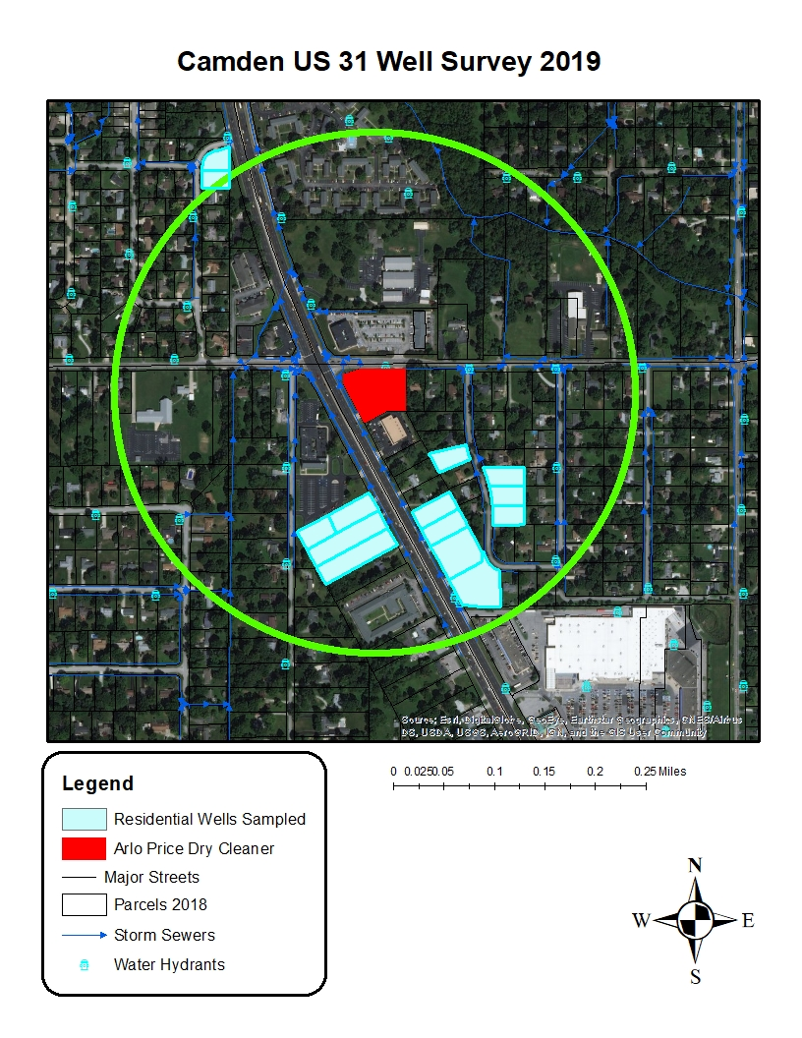
¼ mile radius of 7007 US 31 S. showing residential wells sampled and surrounding parcels.
PERC was not detected in any residential wells sampled at this time.

