Children aged 0-4 saw a 35% increase in RSV ED visits and a 12% increase in Influenza-Like Illness (ILI) in Marion County during Week 47.
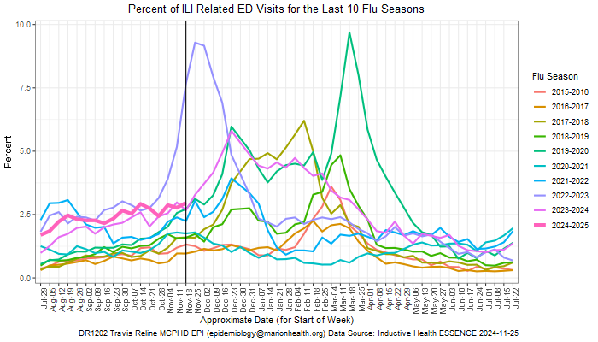

- During Week 47 (November 17 to November 24), 2.96% or 385 of Marion County ED visits had ILI symptoms. The current percentage is higher than last week (2.77% or 360 visits). The median percentage of ILI-related ED visits for Week 47 over the last five years is 2.96%.
- In Marion County hospitals, the age group 0-4 years old had the highest percentage of ILI-related ED visits at 8.54% (105 visits), followed by 5-17 years old at 5.79% (98 visits). Last week, the age group 0-4 years old had the highest percentage of ILI-related ED visits at 7.53% (91 visits). The median percentage of 0-4 years old ILI-related ED visits for Week 47 over the last five years is 9.17%.
- ED visits for Respiratory Syncytial Virus (RSV) for 0-4 years old increased during the last week by 35%. The percentage of RSV-related ED visits was 1.38% (17 visits) out of all 0-4 years old ED visits during Week 47. This percentage is higher than last week (0.91%).
  - RSV is a common respiratory virus that is the most common cause of bronchiolitis and pneumonia for children under one year of age in the U.S.

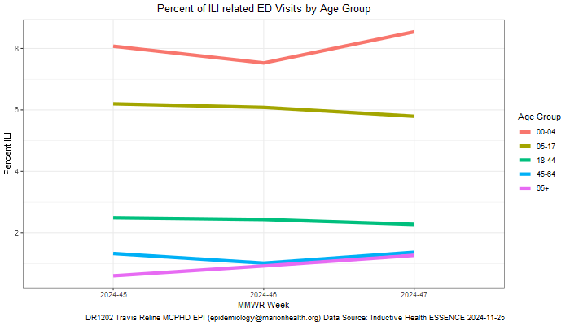

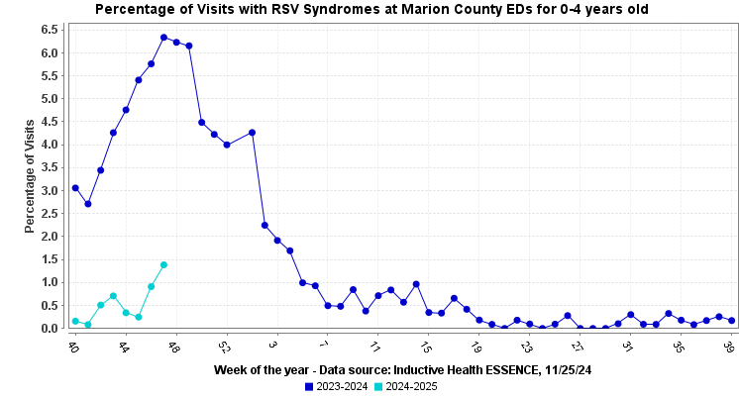

Marion County (Week 46, November 10, 2024 – November 16, 2024)
- The percentage of ILI-related ED visits was 2.77% (360 visits) out of all ED visits.
- In Marion County hospitals, the age group 0-4 years old had the highest percentage of ILI- related ED Visits (7.53% or 91 visits).

Indiana (Week 46, November 10, 2024 – November 16, 2024) https://www.in.gov/health/idepd/influenza/influenza-dashboard/

- Indiana is experiencing LOW ILI activity for Week 46.
- IDOH reported 2.19% ILI at sentinel provider sites and 2.38% ILI at ED and urgent care visits.
- Two influenza-associated deaths have been reported during Week 46. Two deaths have been reported since the beginning of the season.
- Five specimens were tested at the IDOH Laboratory during Week 46:
  - All specimens (100%) were detected as “Negative”
National (Week 46, November 10, 2024 – November 16, 2024)
https://www.cdc.gov/fluview/

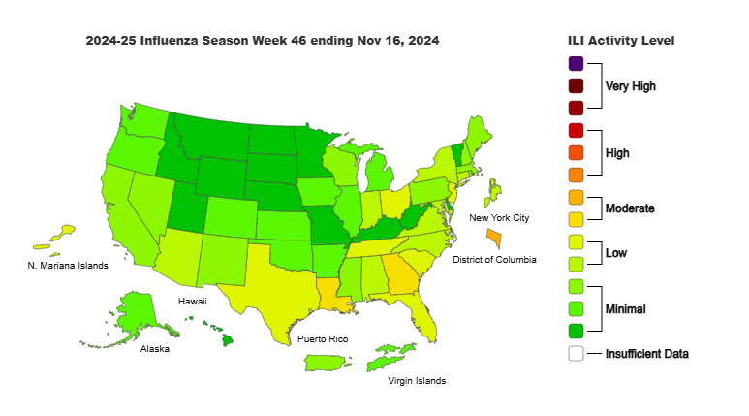

- Seasonal influenza activity is increasing slightly among children but remains low nationally.
- According to the U.S. Outpatient Influenza-like Illness Surveillance Network (ILINet), 2.7% of outpatient visits to healthcare providers were related to ILI (influenza-like illness). This percentage is below the baseline of 3.0%.
- One pediatric death occurred during the 2024-2025 season have been reported to CDC during Week 46
  - Total number of influenza-associated pediatric deaths that have occurred since the beginning of the 2024-2025 season and reported to CDC: Two
- During Week 46, 2.1% of clinical laboratory specimens were positive for the influenza virus. This percentage is higher than last week (1.6%).
- During Week 46, 309 (31.12%) specimens were positive for influenza viruses at public health laboratories. This percentage is higher than last week (21.10%).

