Reasons To Test Water | Tests Needed | Public Cost | Bottle Needed
- Recurring gastro-intestinal illness  - Flu-like symptoms  - Skin rashes  - Storm water runoff nearby | Pools - Bacteria  HPC, Total Coliform/E. coli | $30 per bottle | 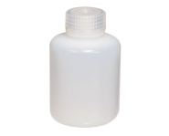
- Recurring gastro-intestinal illness  - Flu-like symptoms  - Nearby areas of intensive agriculture  - Leakage from septic tanks or sewage | Non-pool* -Bacteria  Total Coliform/E. coli  *SW & Wells | $10 per bottle | 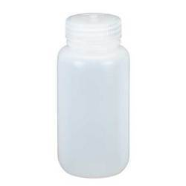
- Corrosion of pipes, plumbing  - Coal or other mining operations nearby  - Dump, junkyard, landfill, factory, gas station, or dry-cleaning operation nearby  - Erosion of natural deposits, runoff from glass and electronics production wastes  - Hazardous waste sites, chemical plants, or factories nearby  - Health problems including stomach cramps, skin discoloration/irritation, headaches, vomiting/nausea, difficulty in breathing, muscle weakness, and kidney damage  - Household plumbing contains lead  - Objectionable taste or smell  - Rust colored stains  - Stained plumbing fixtures, laundry  - Water softener needed to treat hardness | Metals  Arsenic  Barium  Cadmium  Chromium  Iron  Lead  Mercury  Copper | $10 per bottle
- Dump, junkyard, landfill, factory, gas station or drilling, or dry-cleaning operation nearby  - Erosion of natural deposits, possibly from intensive agriculture  - Health problems including bone tenderness, pain, and fractures, high pressure, and shortness of breath  - Leakage from septic tanks or sewage  - Fluoride content to determine need for supplements in wells  - Salty taste and seawater, or a heavily salted roadway nearby  - Water softener use detection | Anions  Chloride  Fluoride  Nitrate  Nitrite  Phosphate  Sulfate | $10 per bottle

